CSE301 Biocomputation, 2016
Week 4 Tutorial Exercises on Perceptron

Part 1. Answer the following questions
- What is required for a data set to be called linearly separable? Show two example sets: one which is linearly separable and one which is not

Answer:
All data points of a class must be on the same side of a hyperplane. The XOR-problem can not be separated and the case of one class above 5 and the other class below 5 can be separated.

- Both the Perceptron Learn Rule and the Delta Rule can solve problems which are linearly separable. Write down the formulae for the two rules, defining each term, and outline the main differences between the Perceptron Learn Rule and the Delta Rule.

ANSWER: bookwork
-differences in error values and step size effect

- The Multi-Layered Perceptron is one of the most commonly used neural network paradigm. Discuss why a Multi-Layered Perceptron may be better than a Single -Layered Perceptron (with no hidden-layers). Give one real-world example to justify your answer, and list the key steps of an appropriate learning algorithm you would use. [2,6]

- Answer: Bookwork & Problem solving - SLP can form only linearly separable classifications, whereas the MLP can form arbitrarily complex non-linear decision boundaries. Use any real-We did not show a clear cohesion between different things in last version. The main subject of this proposal is studying the possible combination of CNNs and probabilistic model. The methodology can be further applied in 1. Attributes reasoning. 2. Weakly supervised scene recognition. 3. Contextual information blending. The three sub-targets are closely related with the methodology mentioned above.
example to demonstrate this, e.g. XOR problem, and outline the MLP learning algorithm employed (e.g. Back Propagation)

- Describes the process of classifying a test example using a feed-forward neural network that uses back-propagation learning?

Answer:
- Forward propagation of signal/data: Activation values are propagated from the input nodes through the hidden layers to the output nodes.
- Backward propagation of error signal: weights on the connections are modified based on the error values propagated from output nodes to input nodes.

- In the Back-Propagation learning algorithm, what is the objective of the learning? Does the Back-Propagation learning algorithm guarantee to find the global optimum solution?

Answer:

The objective is to learn the weights of the interconnections between the inputs and the hidden units and between the hidden units and the output units. The algorithms attempt to nimize the squared error between the network output values and the target values of these outputs.

The learning algorithm does not guarantee to find the global optimum solution. It guarantees to find at least a local minimum of the error function

- Back-propagation minimizes what quantity? Does the back-propagation algorithm, when run until a minimum is achieved, always find the same solution no matter what the initial set of weights are? Briefly explain why or why not.

Answer:
Minimizes the sum-squared error between the output of the network and the desired output.
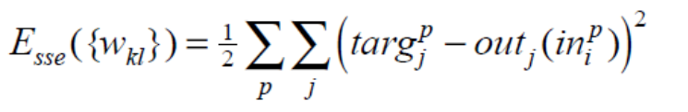
No. It will iterate until a local minimum in the squared error is reached.

- Multilayer perceptrons with non-linear activation functions have universal approximation capacity. Why does the backprop algorithm sometimes not find the set of weights that gives a sufficiently good solution despite the fact that a solution exists?
Answer:
BP performs a gradient descent. This procedure can get stuck in local minima. The local minima do not necessarily represent good enough solutions.

Part II. Answer the following questions
Question 1
Consider a single sigmoid perceptron with bias weight w0=1, a single input x1 with weight w1= -1 (MINUS ONE), and the sigmoid activation function g(h)=1/(1+exp(-h)). For what input x1 does the perceptron output value y (assume 0<y<1)?

Answer:
g(h)=y
1+exp(-h)=1/y
exp(-h)=1/y-1
h= -log(1/y – 1)
h=1-x1
x1-1=log(1/y-1) ⇒ x1=log(1/y -1)+1
Question 2
The diagram above classifies a group of people according to whether they enjoy playing arcade games ( ) or not ( ). Each data point is a person surveyed, and the axes represent the age (in years) and the salary (in hourly wages) of each respondent.
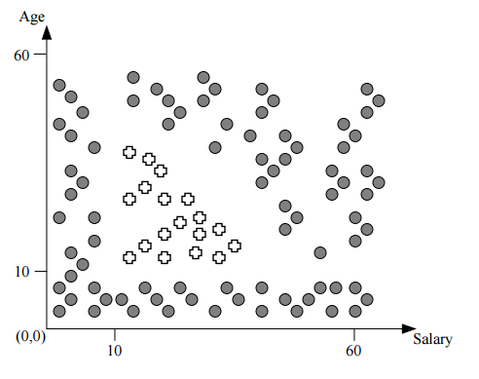
- Can this data be classified using a neural network with no hidden layer? Explain why or why not.

Answer:
This data cannot be classified using a neural network with no hidden layer (a.k.a. a perceptron), because perceptrons are only able to classify data that has a linear separation boundary.

- Based on the diagram from the previous page, draw the simplest neural network that can classify this data, given inputs of age and salary, and outputs of YES (people who like arcade games) and NO (people who don’t like arcade games). Indicate the weights and activation functions for each node in the network.

Answer
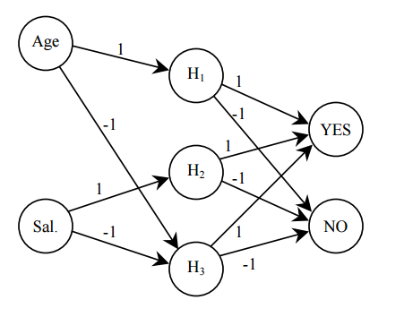
Activation function for H1: Unit step at x=10
Activation function for H2: Unit step at x=10
Activation function for H3: Unit step at x=-60
Activation function for YES: Unit step at x=3
Activation function for NO: Unit step at x=-3

Question 3
You want to design a neural network with sigmoid units to predict a person’s academic role from his webpage. Possible roles are “professor”, “student”, “staff”. However, each person can take any number (from 0 to all 3) of these roles at the same time. Briefly describe
(1) how you would represent the role label of a person in your training data, and
(2) how to convert your neural network output (which will be real values because of the sigmoid units) to the roles.

Answer:
(1) the label of a person can be a vector of three Boolean values (PROF, STUD, STAF), each value can be 0 or 1 independent of the others.
(2) The network needs three output units. Simply threshold each output at 0.5.

Question 4
Given the following neural network with initialized weights as in the picture, explain
the network architecture knowing that we are trying to distinguish between nails
and screws and an example of training tupples is as follows: T1{0.6, 0.1, nail}, T2{0.2,0.3, screw}.

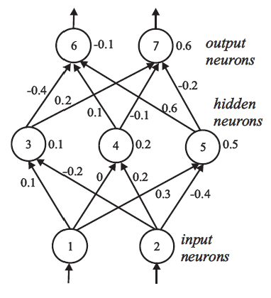
Let the learning rate be 0.1 and the weights be as indicated in the figure above. Do
the forward propagation of the signals in the network using T1 as input, then
perform the back propagation of the error. Show the changes of the weights.

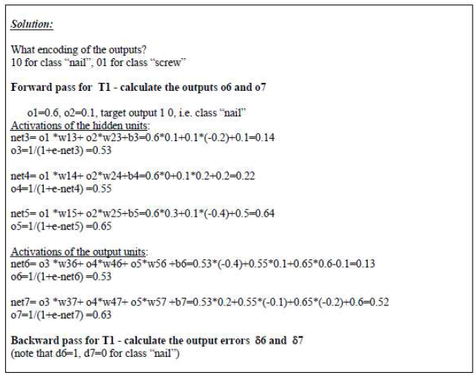
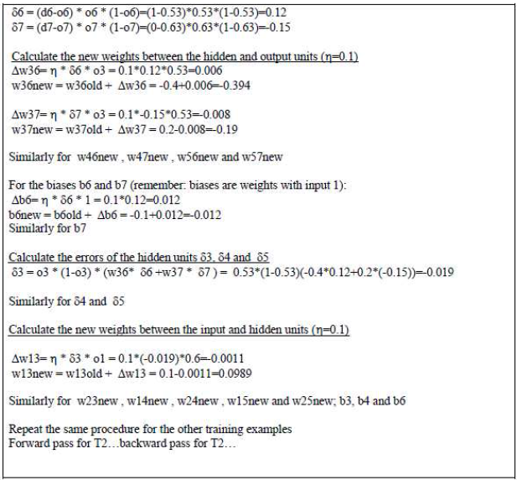

Question 5
You want to use a multi-layer perceptron to predict future values for the water temperature in a lake. To your disposal you have data with air and water temperature as well as sunlight-hours, day by day, for several years. You may assume that the water temperature one day only depends on these three factors, and that data from the most recent 5 days back is sufficient to predict the water temperature that day. How will you proceed to make a good prognosis for the water temperature of the next day using the network? In particular, show what you use as input data and as output data and what values you use to train the network. What learining rule do you use?

Answer:
input:
T_air_t0
T_water_t0
sun_H_t0
T_air_t-1
T_water_t-1
sun_H_t-1
T_air_t-2
T_water_t-2
sun_H_t-2
T_air_t-3
T_water_t-3
sun_H_t-3
T_air_t-4
T_water_t-4
sun_H_t-4
T_air_t-5
T_water_t-5
sun_H_t-5

output:
T_water_t+1

Use a multi-layer perceptron trained with the BP algorithm.
Start with 3 hidden nodes, increase and compare performance.
Segment the data using cross validation: a large set for training, a smaller set for test, and a smaller set for end test. Use data from 6 days (today and 5 days back) to predict tomorrow (use the data for that 7th day as correct answer).

Q3+uestion 6
Suppose we want to classify potential bank customers as good creditors or bad
creditors for loan applications. We have a training dataset describing past customers
using the following attributes: Marital status {married, single, divorced}, Gender
{male, female}, Age {[18..30], [30..50], [50..65],[65+]}, Income {[10K..25K], [25K..50K], [50K..65K], [65K..100K], [100K+]}.

Design a neural network that could be trained to predict the credit rating of an
applicant.

Input： 3+2+4+5 = 14
Output： 2
Hidden： (input+output)/2 = (14+2)/2 = 8
